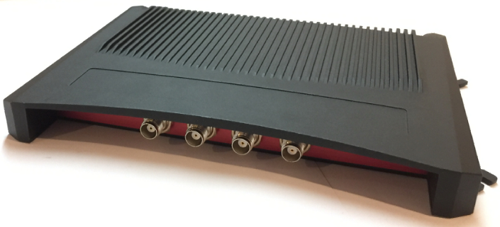

Product name: High Performance UHF RFID Fixed Reader
Product number: CF-RU6403
SIZE: 270x180x27mm

GENERAL DESCRIPTION
UHF High Performance Fixed Reader UHFReader288MP is designed upon fully self-intellectual property. Based on proprietary efficient digital signal processing algorithm, it supports fast tag read/write operation with high identification rate. RRU2882LITE can be widely applied in many RFID application systems such as logistics, access control, anti-counterfeit and industrial production process control system.

FEATURES
- Self-intellectual property;
- 840~960MHz frequency band (frequency customization optional);
- Based on Impinj R2000 high performance RF engine, excellent multi-tag anti-collision operation, fully support EPC CLASS1 G2 \ ISO18000-6B protocol tags
- FHSS or Fix Frequency transmission, support RSSI, Maximum inventory speed over 700pcs;
- RF output power up to 33dbm (adjustable);
- Support 4 TNC antenna port with antenna auto-tuning and failure-detection;
- Support answer and real-time-inventory work mode;
- Tag buffer: 1000pcs@96bitsEPC;
- Support EPC and TID anti-collision mode
- Low power dissipation with single +9 DC power supply, POE (Power over Ethernet) is optional;
- Support RS232, USB(Slave), RJ45 (TCP/IP) interface;
- Provide DLL and Demonstration Software Source code to facilitate further development;
- High reliability design, meet the requirements of harsh working environment.

CHARACTERISTICS
- Absolute Maximum Rating
ITEM | SYMBOL | VALUE | UNIT
Power Supply | VCC | 16 | V
Operating Temp. | T_{OPR} | -20~+55 | ℃
Storage Temp. | T_{STR} | -20~+85 | ℃
- Electrical and Mechanical Specification
Under T_{A}＝25℃，VCC＝+9V unless specified
ITEM | SYMBOL | MIN | TYP | MAX | UNIT
Power Supply | VCC | 8 | 9 | 12 | V
Current Dissipation | IC |  | 0.5 | 1.2 | A
Frequency | F_{REQ} | 840 | 860~868  902~928 | 960 | MHz
Size | L x W x H |  | 268 x181 x28 |  | mm

INTERFACE
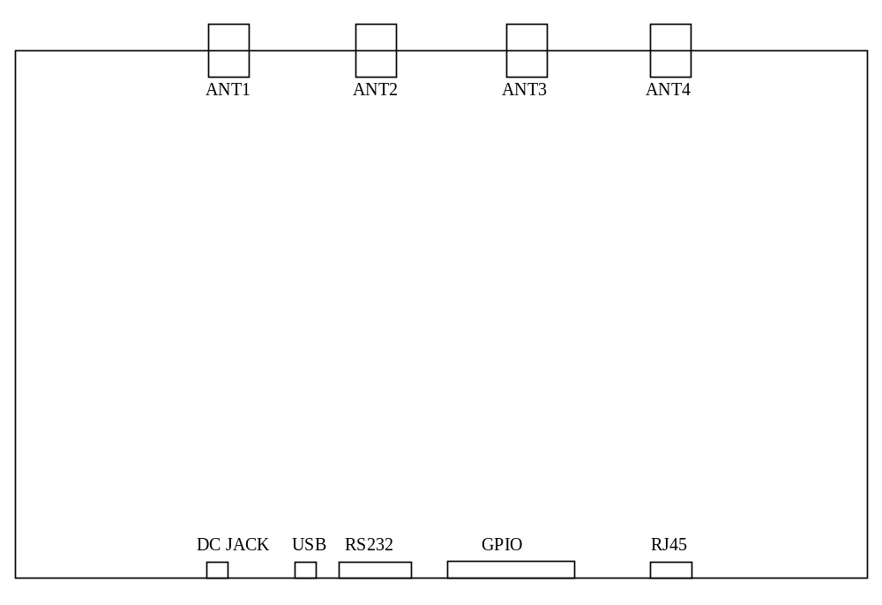
1．Power (DC JACK)
No. | Symbol | Comment
Central | PWR | +9VDC
Outer | GND | Ground
2．USB
3. UART （RS232 DB9 Female）
No. | Symbol | Comment
1 | NC | Reserved
2 | TXD | Data output in RS232
3 | RXD | Data input in RS232
4 | NC | Reserved
5 | GND | Ground
6 | NC | Reserved
7 | NC | Reserved
8 | NC | Reserved
9 | NC | Reserved
4．GPIO （DB15 Female）
No. | Symbol | Comment
1 | NC | Reserved
2 | NC | Reserved
3 | Input1－ | General OPTO-coupler isolated input -
4 | Input2－ | General OPTO-coupler isolated input -
5 | Output1 | General OPTO-coupler isolated Output1
6 | Output1 | General OPTO-coupler isolated Output1
7 | Output2 | General OPTO-coupler isolated Output2
8 | Output2 | General OPTO-coupler isolated Output2
9 | Input1＋ | General OPTO-coupler isolated input+  with internal pull-up to 3.3V through a 1k resistor
10 | Input2＋ | General OPTO-coupler isolated input+  with internal pull-up to 3.3V through a 1k resistor
11 | NC | Reserved
12 | GND | Ground
13 | NC | Reserved
14 | NC | Reserved
15 | NC | Reserved
5．TCPIP network (RJ45)

6．TNC antenna port ANT1~ANT4

